Easy Read – Planning with you
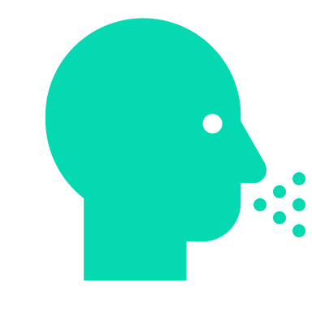 | Your voice is the essential
 | Please tell us about your needs and requirements.
 | Your Support Plan is designed with you at the centre of all actions.
 | Our staff will look at your current NDIS Plan funding to ensure that we have the services you need.
 | To create your plan, we may need to talk to your family, health providers and others (with your permission)
We will consult with you about many supports such as:
- Living skill development
- Your interests, leisure and community group involvement
- Travelling and transport needs
We will consult about:
- Family relationships
- Cultural requirements, e.g. food,
- Spiritual Identity – religious needs
- Communication methods
Your safety is checked:
- Physical environment
- Personal emergency plan
Your health needs are assessed:
- Medical needs
- General health requirements
- High-intensity requirements
- Allied health services
- Comprehensive health
- Vaccination support
- Oral health
 | We look for risks so we can get rid of or reduce them
 | We will create risk strategies and train our staff in these
 | Your Support Plan is reviewed every year
 | If your needs change, then we will review your plan earlier
 | You will need to sign your Support Plan
 | We will provide you with a copy of the Support Plan

