Easy Read – Risk Assessment
 | Your safety is essential to your support
Assessing risks to you will occur regularly.
Your risk assessment starts at your initial intake, then at least annually.
 | When your situation changes, we will undertake another risk assessment.
 | A risk is when it is probable that a specific event or activity may lead to you or someone else being hurt.
We assess risks by asking:
- What could go wrong?
- How often?
- How bad?
- Is there action needed?
 | A strategy will be written for any risk and recorded in your Support Plan.
 | We will discuss your risks and their strategies with you.
 | If we think an activity has high real or potential risk. We will talk to you about the risks. You can agree to undertake this activity (Informed-Consent)
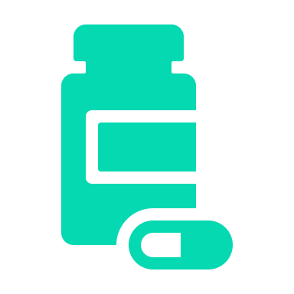 | Your environment is checked for:  - Trips and falls  - Electrical issues – cords  - Hot water temperature  - Medication storage  - Pets  - Physical environment – stairs etc

Your emotional environment is checked to ensure the people around you are supportive and not hurting you.
We look for risks so we can get rid of or reduce them
We will create and train staff in your risk strategies
If your needs change, then we will review your risks earlier

